WEDE5020

POE Assignment

Madimetja Mantjiu

ST10483045

Retail Store

**SneakDistrict**

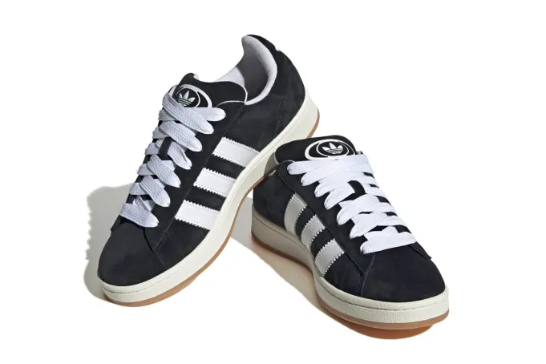

**Reason for business**

Adidas has built a legacy through sports, music, and street culture, so their sneakers already carry built-in demand and status.

**High Demand & Popularity** – Adidas classics (like Sambas, Superstars, Gazelles) and collabs (like Yeezy, Bad Bunny, Gucci) are always trending. People want them for both fashion and function.

**Brand Trust** – Adidas is a well-known worldwide brand that has been trusted for more than 70 years. Customers already trust Adidas sneakers, so they don't need to be persuaded of their quality.

**Profit Potential** – Sneakers can be sold for twice or three times their regular price due to limited releases and collaborations. Because of this, it is not just motivated by passion but also produces money.

Home Page

**Name: SneakerDistrict**

**Logo:**

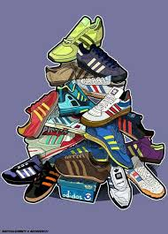

**Slogan:** Built for the streets. Styled for the culture.

Welcome to Sneaker District, a place where culture and fashion collide. Here, each pair is more than simply kicks—it's individuality; each step narrates a tale; and each drop is heat. You'll find what you're looking for here, whether you're searching for limited editions, classics, or something unique. Take over. Put on your shoes. Take control of the streets.

#SneakerDitstrict #Built for the street. #Styled for the culture.

About us

History of business and why it was established

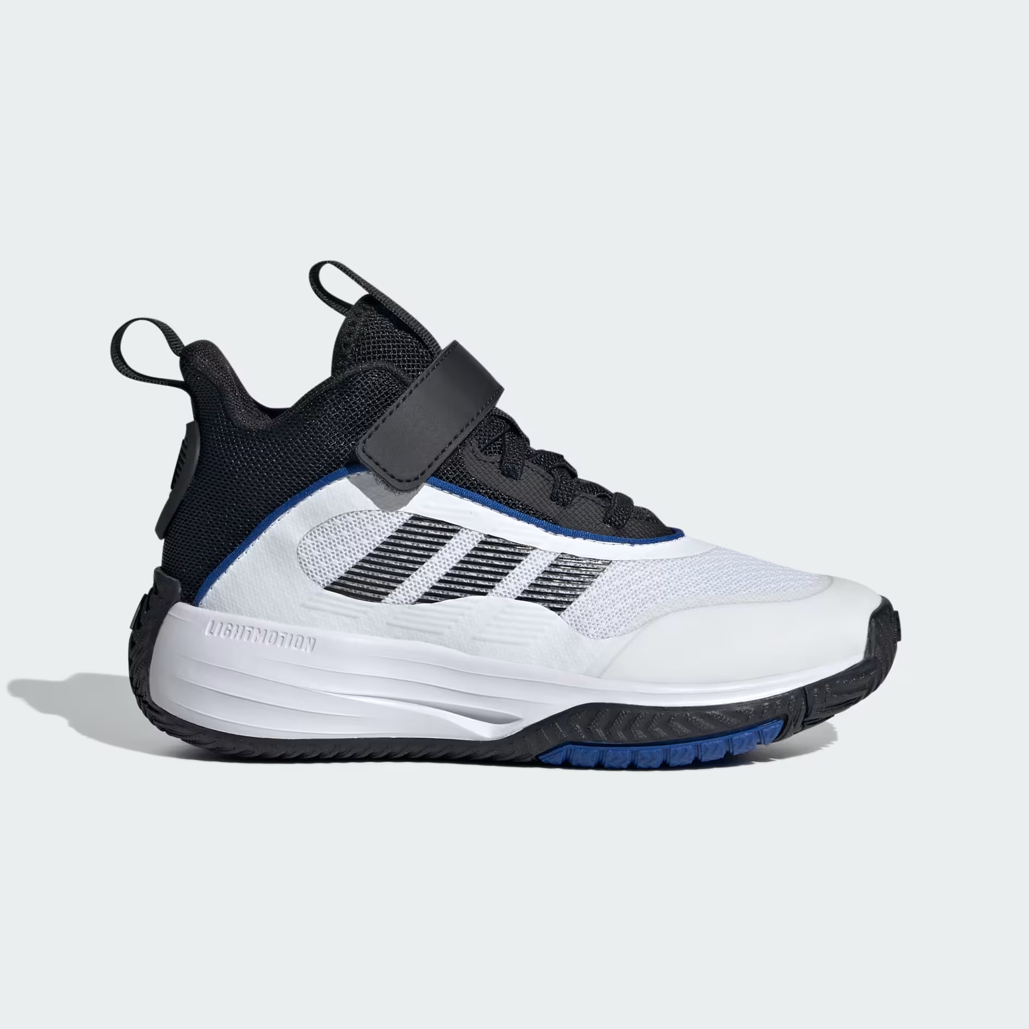

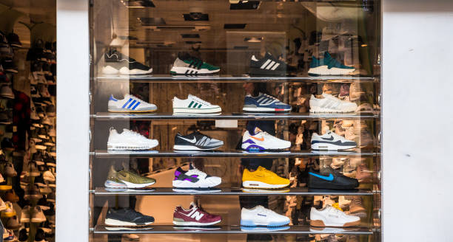

I , the owner of the online retail store “SneakerDistrict” started the business because of the love I have for Adidas sneakers hence why I created the business that strictly sells Adidas sneakers.

Co-Values:

**Compassion:**  
 At SneakerDistrict, we believe in more than just sneakers — we care about people. We treat every customer with kindness, understanding, and respect, creating a community where everyone feels valued and included.

**Reliability:**  
 We keep our promises. From authentic products to timely service, SneakerDistrict is built on consistency and dependability you can count on every time.

**Trustworthiness:**  
 Honesty is at the heart of our business. At SneakerDistrict, we earn your trust through integrity, transparency, and a commitment to delivering only the real deal.

**Safety:**  
 Your peace of mind matters. Whether you’re shopping in-store or online, SneakerDistrict ensures a secure, safe, and welcoming environment for every sneaker enthusiast.

SneakerDistrict operating hours: 8:00-20:00

Product images

Adidas Samba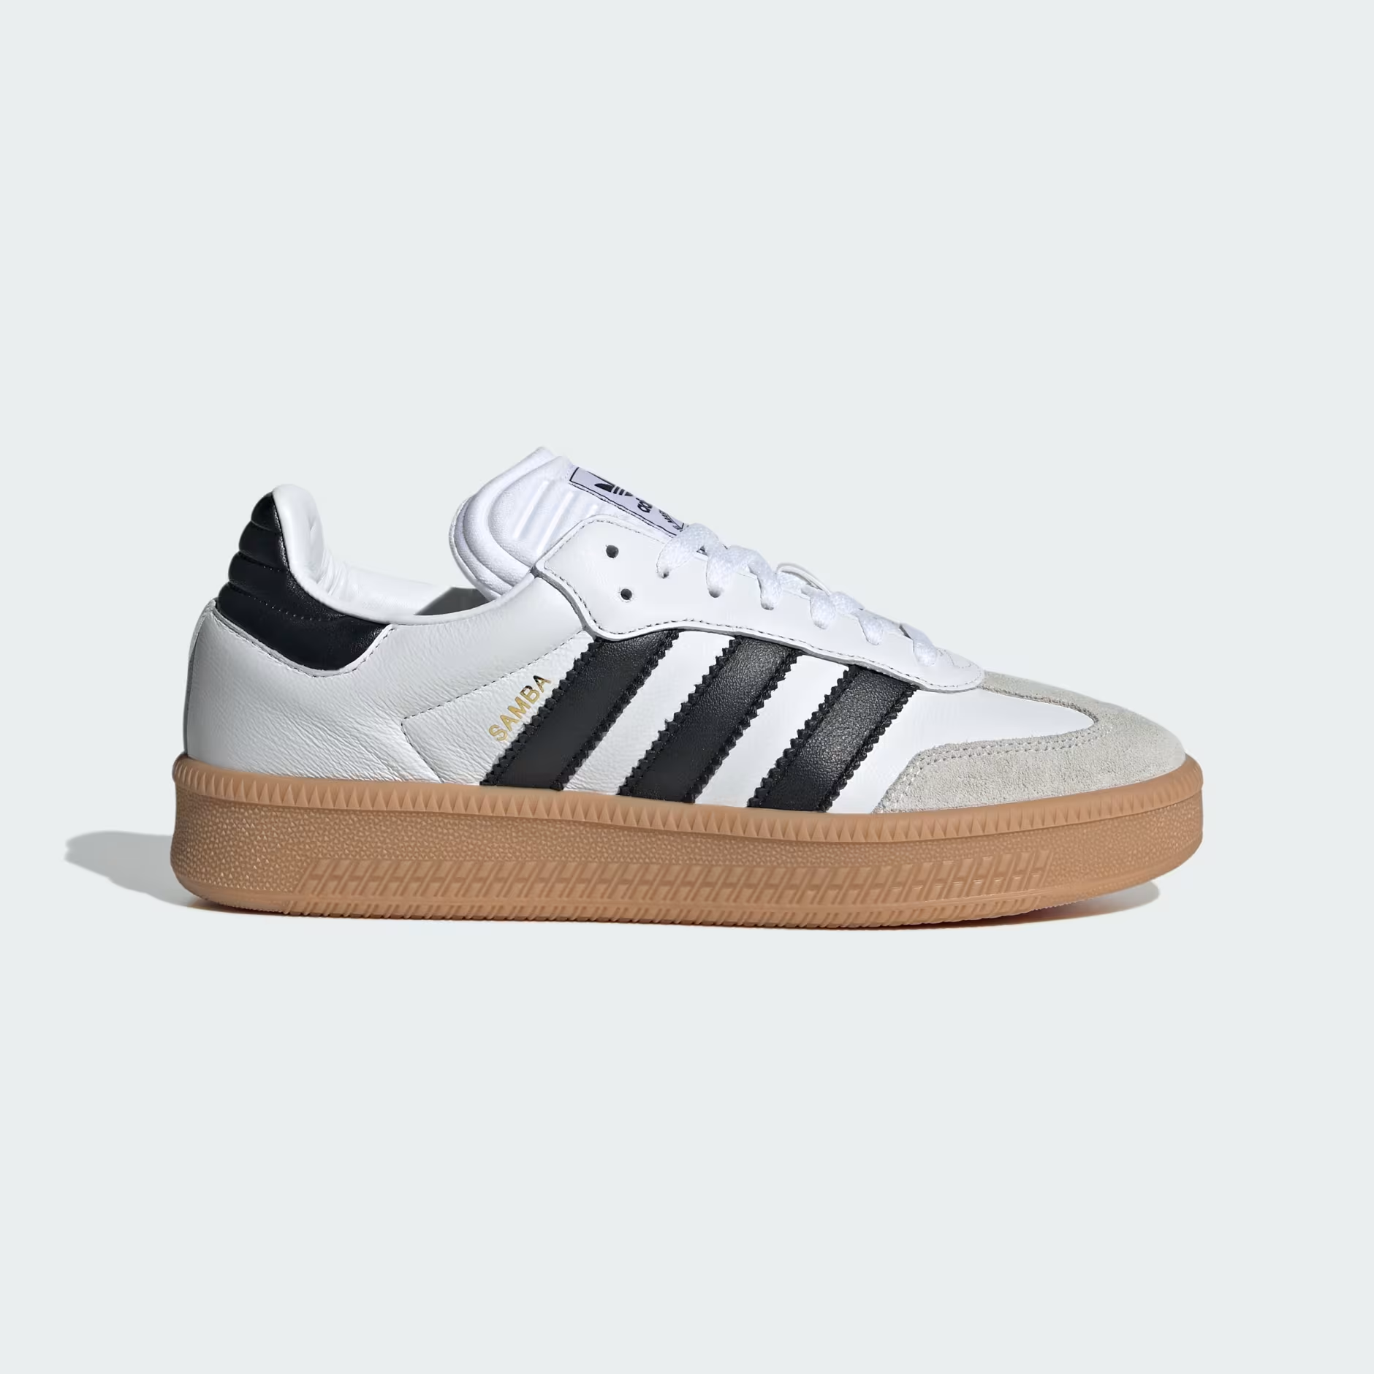

Adidas Campus

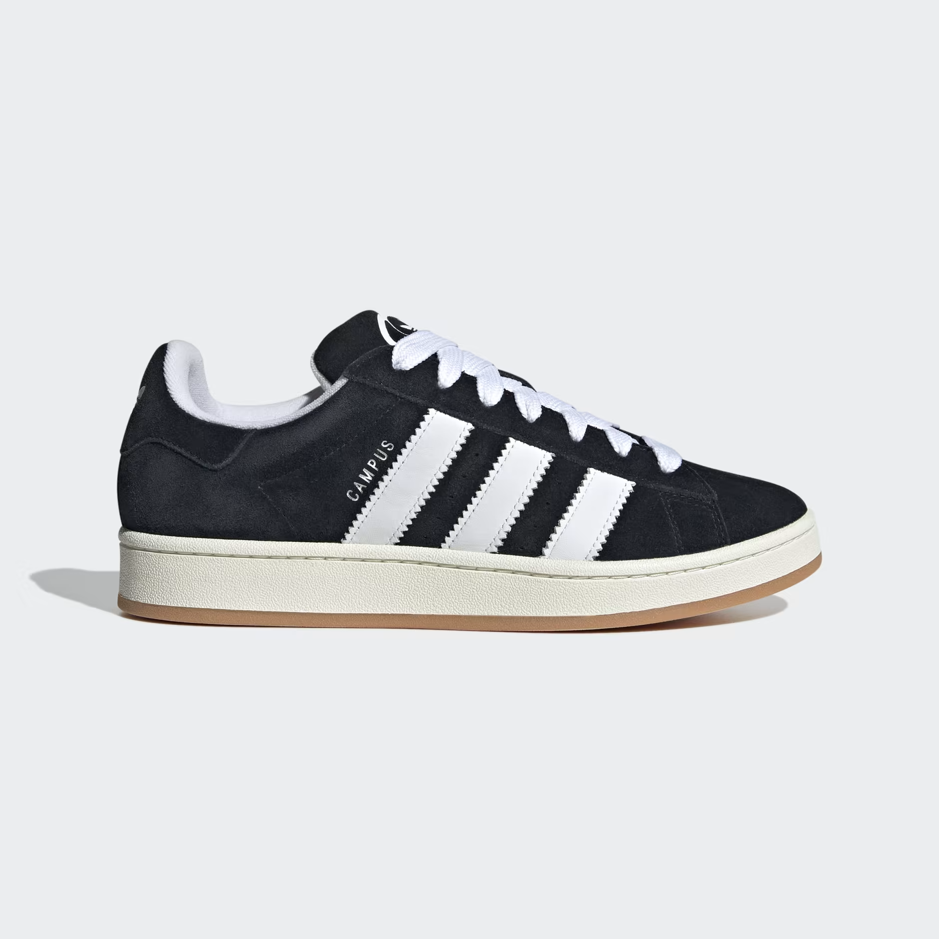

Adidas Forum low

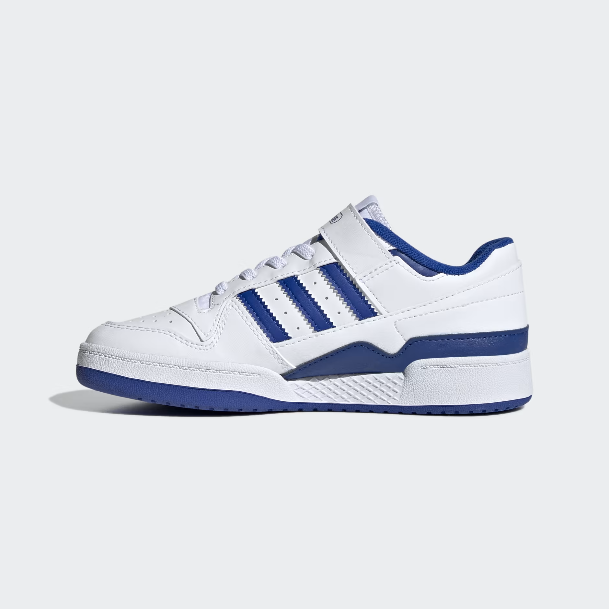

And many more.

**Contact us on**

Contact details: 067 159 5648

Location: Tembisa

Services

About us

Contact us

Index

Gallery

Get involved

**Adidas (n.d.)** *Ultraboost 1.0 Shoes*. Available at: <https://www.adidas.com/us/ultraboost-1.0-shoes/HQ4207.html> (Accessed: 25 August 2025).

**Adidas (n.d.)** *Ultraboost Shoes*. Available at: <https://www.adidas.com/us/ultraboost> (Accessed: 25 August 2025).

**Wikipedia (2024)** *Adidas Ultraboost*. Available at: <https://en.wikipedia.org/wiki/Adidas_Ultraboost> (Accessed: 25 August 2025).

**Wikipedia (2025)** *Adidas*. Available at: <https://en.wikipedia.org/wiki/Adidas> (Accessed: 25 August 2025).

Author: Madimetja Mantjiu

Est: 2025

Contact us on: 0671595648

Email: [Metja@sneakerdistrict.co.za](mailto:Metja@sneakerdistrict.co.za)